**NEW LOWER SECONDARY CURRICULUM**

**NAME………………………………………………………………………CLASS…………………**

**545/1**

**Chemistry**

**Paper 1**

**Nov 2023**

**CHEMISTRY DEPARTMENT**

**CHEMISTRY**

**END YEAR EXAMINATION**

**FORM THREE**

**2 HOURS**

**Instructions to item takers**

This paper consists of four extended scenario items.

Attempt all the items

Write your responses in the spaces provided.

|  |  |  |  |  |  |
| --- | --- | --- | --- | --- | --- |
| **For official use only** | | | | | |
| **Item No.** | **1** | **2** | **3** | **4** | **Total score** |
| **Score** |  |  |  |  |  |

1. Carbohydrates are always consumed as food in our homes but also have other uses. Kampala metropolitan area is infested by bacteria that causes typhoid. Typhoid spreads through contaminated water and food. The District health officer advised washing hands using sanitizers to kill the bacteria. Commercial sanitizer is expensive and the community members wish to produce their own sanitizer but do not know how it can be produced.

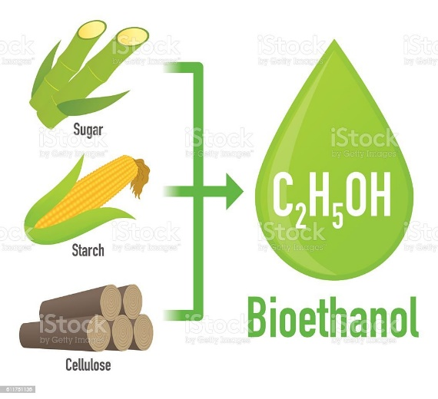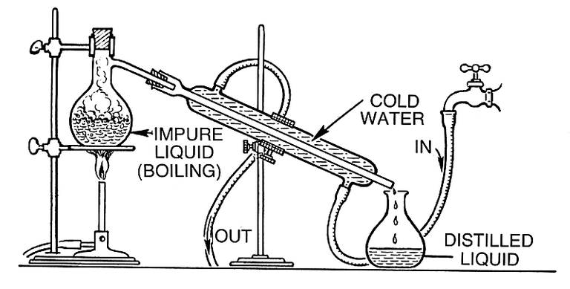

**TASK:**

As a student of Chemistry, educate the community members on how to go about it.

………………………………………………………………………………………………………………………………………………………………………………………………………………………………………………………………………………………………………………………………………………………………………………………………………………………………………………………………………………………………………………………………………………………………………………………………………………………………………………………………………………………………………………………………………………………………………………………………………………………………………………………………………………………………………………………………………………………………………………………………………………………………………………………………………………………………………………………………………………………………………………………………………………………………………………………………………………………………………………………………………………………………………………………………………………………………………………………………………………………………………………………………………………………………………………………………………………………………………………………………………………………………………………………………………………………………………………………………………………………………………………………………………………………………………………………………………………………………………………………………………………………………………………………………………………………………………………………………………………………………………………………………………………………………………………………………………………………………………………………………………………………………………………………………………………………………………………………………………………………………………………………………………………………………………………………………………………………………………………………………………………………………………………………………………………………………………………………………………………………………………………………………………………………………………………………………………………………………………………………………………………………………………………………………………………………………………………………………………………………………………………………………………………………………………………………………………………………………………………………………………………………………………………………………………………………………………………………………………………………………………………………………………………………………………………………………………………………………………………………………………………………………………………………………………………………………………………………………………………………………………………………………………………………………………………………………………………………………………………………………………………………………………………………………………………………………………………………………………………………………………………………………………………………………………………………………………………………………………………………………………………………………………………………………………………………………………………………………………………………………………………………………………………………………………………………………………………………………………………………………………………………………………………………………………………………………………………………………………………………………………………………………………………………………………………………………………………………………………………………………………………………………………………………………………………………………………………………………………………………………………………………………………………………………………………………………………………………………………………………………………………………………………………………………………………………………………………………………………………………………………………………………………………………………………………………………………………………………………………………………………………………………………………………………………………………………………………………………………………………………………………………………………………………………………………………………………………………………………………………………………………………………………………………………………………………………………………………………………………………………………………………………………………………………………………………………………………………………………………………………………………………………………………………………………………………………………………………………………………………………………………………………………………………………………………………………………………………………………………………………………………………………………………………………………………………………………………………………………………………………………………………………………………………………………………………………………………………………………………………………………………………………………………………………………………………………………………………………………………………………………………………………………………………………………………………………………………………………………………………………………………………………………………………………………………………………………………………………………………………………………………………………………………………………………………………………………………………………………………………………………………………………………………………………………………………………………………………………………………………………………………………

1. Urban areas in Uganda face growing challenges related to waste management and pollution. The improper disposal of wastes has contributed to environmental degradation and health hazards.

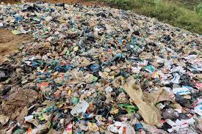 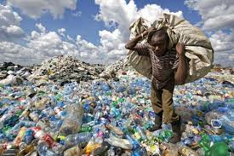

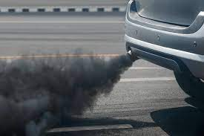 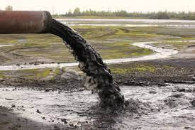 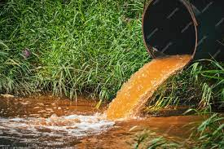 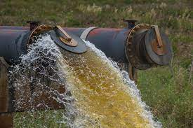

**Task:**

Create an article in your school magazine to address the problem.

……………………………………………………………………………………………………………………………………………………………………………………………………………………………………………………………………………………………………………………………………………………………………………………………………………………………………………………………………………………………………………………………………………………………………………………………………………………………………………………………………………………………………………………………………………………………………………………………………………………………………………………………………………………………………………………………………………………………………………………………………………………………………………………………………………………………………………………………………………………………………………………………………………………………………………………………………………………………………………………………………………………………………………………………………………………………………………………………………………………………………………………………………………………………………………………………………………………………………………………………………………………………………………………………………………………………………………………………………………………………………………………………………………………………………………………………………………………………………………………………………………………………………………………………………………………………………………………………………………………………………………………………………………………………………………………………………………………………………………………………………………………………………………………………………………………………………………………………………………………………………………………………………………………………………………………………………………………………………………………………………………………………………………………………………………………………………………………………………………………………………………………………………………………………………………………………………………………………………………………………………………………………………………………………………………………………………………………………………………………………………………………………………………………………………………………………………………………………………………………………………………………………………………………………………………………………………………………………………………………………………………………………………………………………………………………………………………………………………………………………………………………………………………………………………………………………………………………………………………………………………………………………………………………………………………………………………………………………………………………………………………………………………………………………………………………………………………………………………………………………………………………………………………………………………………………………………………………………………………………………………………………………………………………………………………………………………………………………………………………………………………………………………………………………………………………………………………………………………………………………………………………………………………………………………………………………………………………………………………………………………………………………………………………………………………………………………………………………………………………………………………………………………………………………………………………………………………………………………………………………………………………………………………………………………………………………………………………………………………………………………………………………………………………………………………………………………………………………………………………………………………………………………………………………………………………………………………………………………………………………………………………………………………………………………………………………………………………………………………………………………………………………………………………………………………………………………………………………………………………………………………………………………………………………………………………………………………………………………………………………………………………………………………………………………………………………………………………………………………………………………………………………………………………………………………………………………………………………………………………………………………………………………………………………………………………………………………………………………………………………………………………………………………………………………………………………………………………………………………………………………………………………………………………………………………………………………………………………………………………………………………………………………………………………………………………………………………………………………………………………………………………………………………………………………………………………………………………………………………………………………………………………………………………………………………………………………………………………………………………………………………………………………………………………………………………………………………………………………………………………………………………………………………………………………………………………………………………………………………………………………………………………………………………………………………………………………………………………………

1. Common salt (sodium chloride) is an additive in food to make it tasty. A student of senior one expressed the interest in making common salt from its elements as his project but lacks the knowledge. The student approached the laboratory technician who promised to help her the next day. Unfortunately, the laboratory technician did not appear to school the next day.

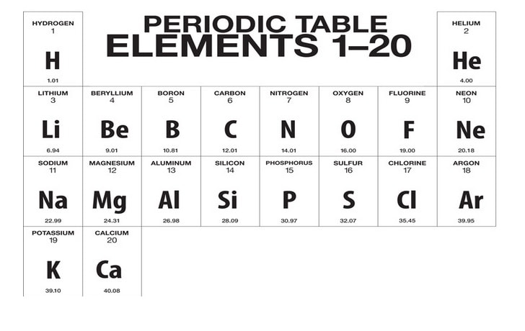

**Task**

Act as the laboratory technician and help the student to achieve her aim.

…………………………………………………………………………………………………………………………………………………………………………………………………………………………………………………………………………………………………………………………………………………………………………………………………………………………………………………………………………………………………………………………………………………………………………………………………………………………………………………………………………………………………………………………………………………………………………………………………………………………………………………………………………………………………………………………………………………………………………………………………………………………………………………………………………………………………………………………………………………………………………………………………………………………………………………………………………………………………………………………………………………………………………………………………………………………………………………………………………………………………………………………………………………………………………………………………………………………………………………………………………………………………………………………………………………………………………………………………………………………………………………………………………………………………………………………………………………………………………………………………………………………………………………………………………………………………………………………………………………………………………………………………………………………………………………………………………………………………………………………………………………………………………………………………………………………………………………………………………………………………………………………………………………………………………………………………………………………………………………………………………………………………………………………………………………………………………………………………………………………………………………………………………………………………………………………………………………………………………………………………………………………………………………………………………………………………………………………………………………………………………………………………………………………………………………………………………………………………………………………………………………………………………………………………………………………………………………………………………………………………………………………………………………………………………………………………………………………………………………………………………………………………………………………………………………………………………………………………………………………………………………………………………………………………………………………………………………………………………………………………………………………………………………………………………………………………………………………………………………………………………………………………………………………………………………………………………………………………………………………………………………………………………………………………………………………………………………………………………………………………………………………………………………………………………………………………………………………………………………………………………………………………………………………………………………………………………………………………………………………………………………………………………………………………………………………………………………………………………………………………………………………………………………………………………………………………………………………………………………………………………………………………………………………………………………………………………………………………………………………………………………………………………………………………………………………………………………………………………………………………………………………………………………………………………………………………………………………………………………………………………………………………………………………………………………………………………………………………………………………………………………………………………………………………………………………………………………………………………………………………………………………………………………………………………………………………………………………………………………………………………………………………………………………………………………………………………………………………………………………………………………………………………………………………………………………………………………………………………………………………………………………………………………………………………………………………………………………………………………………………………………………………………………………………………………………………………………………………………………………………………………………………………………………………………………………………………………………………………………………………………………………………………………………………………………………………………………………………………………………………………………………………………………………………………………………………………………………………………………………………………………………………………………………………………………………………………………………………………………………………………………………………………………………………………………………………………………………………………………………………………………………………………………………………………………………………………………………………………………………………………………………………………………………………………………………………………………………………………………………………………………………………………………………………………………………………………………………………………………………………………………………………………………………………………………………………………………………………………………………………………………………………………………………………………………………………………………………………………………………………………………………………………………………………………………………………………………………………………………………………………………………………………………………………………………………………………………………………………………………………………………………………………………………………………………………………………………………………………………………………………………………………………………………………………………………………………………………………………………………………………………………………………………………………………………………………………………………………………………………………...

1. In rural village in Uganda, traditional cooking methods such open fires and inefficient local stoves requires a lot of fuel to prepare small quantities of food. This increases the cost of house hold energy consumption, in addition, it has many health and environment effects.

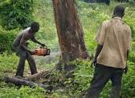 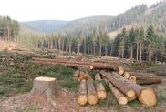

**Task**

Advise the community on how the resource can sustainably be used.

……………………………………………………………………………………………………………………………………………………………………………………………………………………………………………………………………………………………………………………………………………………………………………………………………………………………………………………………………………………………………………………………………………………………………………………………………………………………………………………………………………………………………………………………………………………………………………………………………………………………………………………………………………………………………………………………………………………………………………………………………………………………………………………………………………………………………………………………………………………………………………………………………………………………………………………………………………………………………………………………………………………………………………………………………………………………………………………………………………………………………………………………………………………………………………………………………………………………………………………………………………………………………………………………………………………………………………………………………………………………………………………………………………………………………………………………………………………………………………………………………………………………………………………………………………………………………………………………………………………………………………………………………………………………………………………………………………………………………………………………………………………………………………………………………………………………………………………………………………………………………………………………………………………………………………………………………………………………………………………………………………………………………………………………………………………………………………………………………………………………………………………………………………………………………………………………………………………………………………………………………………………………………………………………………………………………………………………………………………………………………………………………………………………………………………………………………………………………………………………………………………………………………………………………………………………………………………………………………………………………………………………………………………………………………………………………………………………………………………………………………………………………………………………………………………………………………………………………………………………………………………………………………………………………………………………………………………………………………………………………………………………………………………………………………………………………………………………………………………………………………………………………………………………………………………………………………………………………………………………………………………………………………………………………………………………………………………………………………………………………………………………………………………………………………………………………………………………………………………………………………………………………………………………………………………………………………………………………………………………………………………………………………………………………………………………………………………………………………………………………………………………………………………………………………………………………………………………………………………………………………………………………………………………………………………………………………………………………………………………………………………………………………………………………………………………………………………………………………………………………………………………………………………………………………………………………………………………………………………………………………………………………………………………………………………………………………………………………………………………………………………………………………………………………………………………………………………………………………………………………………………………………………………………………………………………………………………………………………………………………………………………………………………………………………………………………………………………………………………………………………………………………………………………………………………………………………………………………………………………………………………………………………………………………………………………………………………………………………………………………………………………………………………………………………………………………………………………………………………………………………………………………………………………………………………………………………………………………………………………………………………………………………………………………………………………………………………………………………………………………………………………………………………………………………………………………………………………………………………………………………………………………………………………………………………………………………………………………………………………………………………………………………………………………………………………………………………………………………………………………………………………………………………………………………………………………………………………………………………………………………………………………………………………………………………………………………………………………………

**END**